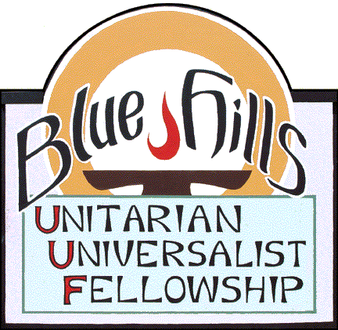  ***AugustCalendar***



***Date Time Program Presenter/facilitator***

August 3 10:00 Cured by Love Rev. Terry Cummings

August 10 10:00 When Free Speech Becomes Hate Speech Irene Asp

August 17 10:00 Rain, Death, Destruction . . . and Humor Dennis Peters

Third Sunday Potluck

August 24 10:00 TBA Arthur Thexton

August 31 !0:00 Revolution Begins with a Dream. GA Worship Rev. Dr. Nicole Kirk

Unitarian Universalists affirm and promote the inherent worth and dignity of every person, as well as justice, equity and compassion in human relations. Yet it isn’t always easy to reconcile these ideals in times of disagreement or change, especially when reasonable minds can differ on the issues at hand. This Sunday, Rev. Terry Cummings will reflect on ways in which we might apply our UU values in such times, with specific reference to an issue that seemingly has been in the news more than ever before, transgender rights and freedoms.

The service on August 10th will feature a discussion about the balance between free speech and hate speech. A short film about how this issue is dealt with in Germany will provide the foundation for our discussion.

Dennis says this about his service: I planned to start this message talking about rain, specifically the song, “Yesterday I Heard the Rain.” But this message took a left turn even though I had both hands on the wheel. I started remembering jokes from over the years about death and disaster. But what’s funny about that? I don’t think it will drag you down.

For our final service of the month, we will view portions of the recording of the Sunday morning worship service at this year’s General Assembly. The Rev. Dr. Kirk, professor of Unitarian history at Meadville-Lombard and resident minister at All Souls Tulsa, provides an uplifting message of how our Unitarian history can provide inspiration to us today as we face the chaos and cruelty of the present moment.

