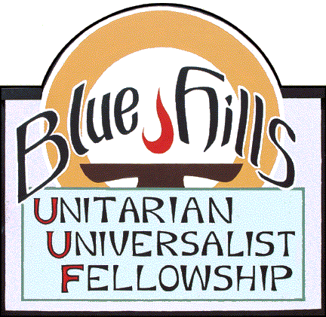
JanuaryCalendar



Date Time Program Presenter/facilitator
January 4 10:00 Unitarian Universalists Face a New Age Rev. Shawn Gautier

January 11 10:00 Book Week All

January 18 10:00 Guiding Light Rev. Doak Mansfield
Third Sunday Potluck

January 25 10:00 Love is Not Enough Judy Barisonzi

This month we will listen to and discuss two recorded services from congregations we have visited virtually in the last year or two. Both these services were given recently in connection with Advent, but their content is equally applicable to the New Year.

First on Jan. 4, we will listen to Rev. Shawn Gautier, speaking to the North Shore Unitarians in Vancouver about the challenges and possibilities facing UUs as we respond to the present moment.

Then on Jan. 18, a very different speaker, Rev. Dr. Doak Mansfield from the UU Church of Tampa, will tell us that "we're born into a story and have to build our own stories within it." Both speakers will draw on UU history to explain the importance of religious community.

In between we will do an old favorite: book week. Everyone is invited to suggest a book to add to our winter reading lists. The suggestions will be put into a document and distributed for easy remembrance.

Finally, Judy asks us to consider this question: Which is a better guide through life for those of us who profess adherence to a liberal religion--emotion or reason? It's not a simple either/or choice.



